CITIZEN AI: INTELLIGENT CITIZEN ENGAGEMENT PLATFORM

Project Description:

Citizen AI uses the Granite model from Hugging Face to give quick, helpful answers about government services and civic issues. It tracks public sentiment and shows simple dashboards for officials to see feedback. This project will be deployed in Google Colab using Granite for easy, low-cost setup and reliable performance.

My team has successfully enrolled for the project. Find the team details below.

Team ID: NM2025TMID06262

Team Size: 4

Team Leader: GOBIKA V

Team member: JAYALAKSHMI K

Team member: LATHIYA S

Team member: MADHUMITHA S

Activity-1: Exploring Naan Mudhalavan Smart Interz Portal.

* + Search for “Naan Mudhalavan Smart Interz” Portal in any Browser.
  + Then Click on the first link.
  + ([Naanmudhalvan Smartinternz](https://naanmudhalvan.smartinternz.com/)) Then login with your details.
  + Then you will be redirected to your account then click on “Projects”
  + Section.
  + There you can see which project you have enrolled in here it is “Citizen AI”.
  + Then click on “Access Resources” and go to the “Guided Project” Section.
  + Click on the “Go to workspace” section.
  + Then you can find the detailed explanation of Generative AI Project using IBM API key.
  + Click on “Project Workspace”, there you can find your project progress and Place to upload “Demo link”.
  + Now we have gone through portal understanding, now lets find a IBM granite model from hugging face to integrate in our project.

Activity-2: Choose a IBM Granite model From Hugging Face.

* Search for “Hugging face” in any browser.
* Then click on the first link ([Hugging Face](https://huggingface.co/)), then click on signup and create your own account in Hugging Face.
* Then search for “IBM-Granite models” and choose any model.
* Here for this project we are using “granite-3.2-2b-instruct” which is compatible fast and light weight.
* Now we will start building our project in Google collab.

Activity-3: Running Application in Google Collab.

* Search for “Google collab” in any browser.
* Click on the first link ([Google Colab](https://colab.research.google.com/)), then click on “Files” and then “Open Notebook”.
* Click on “New Notebook”.
* Change the title of the notebook “Untitled” to “Citizen AI”. Then click on “Runtime”, then go to “Change Runtime Type”.
* Choose “T4 GPU” and click on “Save”.
* Run this command in first cell “!pip install transformers torch gradio -q”.
* To install the required libraries to run our application.
* Then run the rest of the code in the next cell.

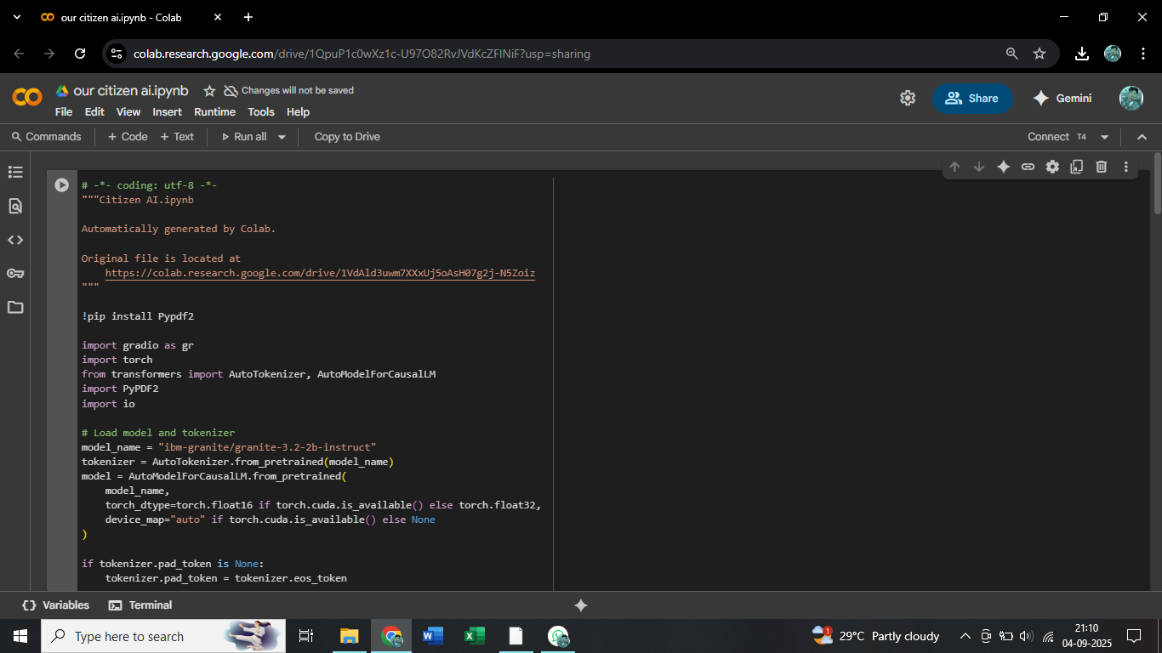

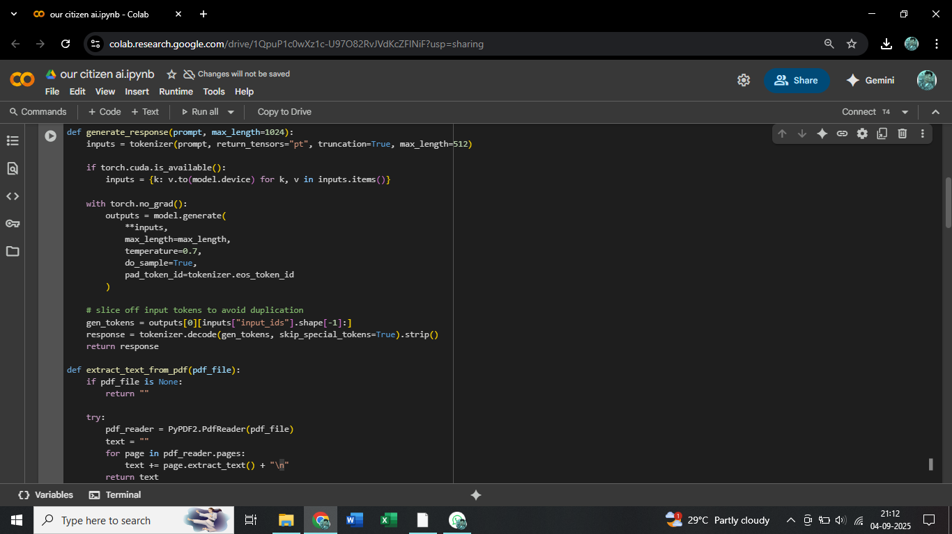

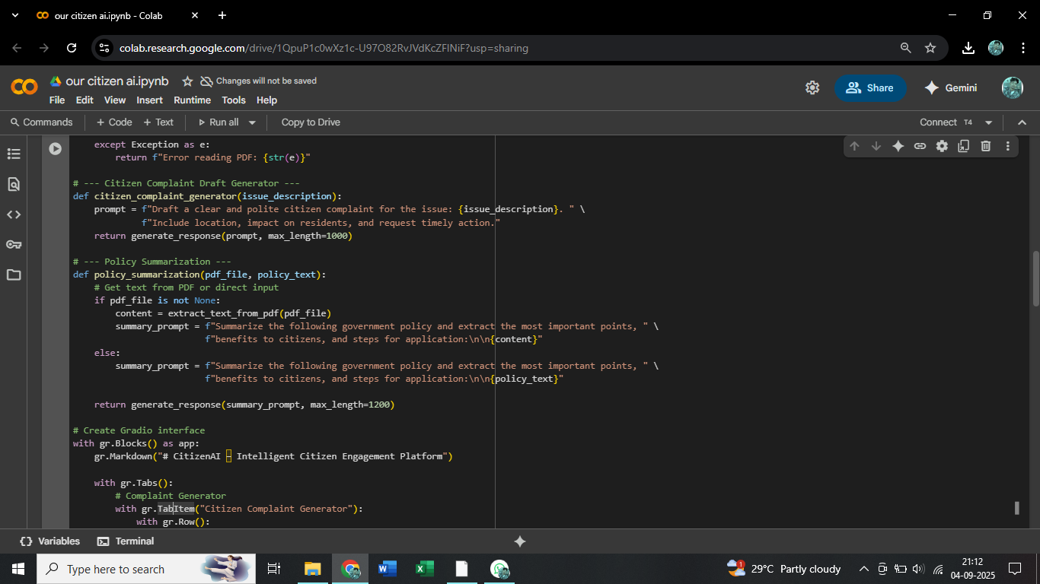

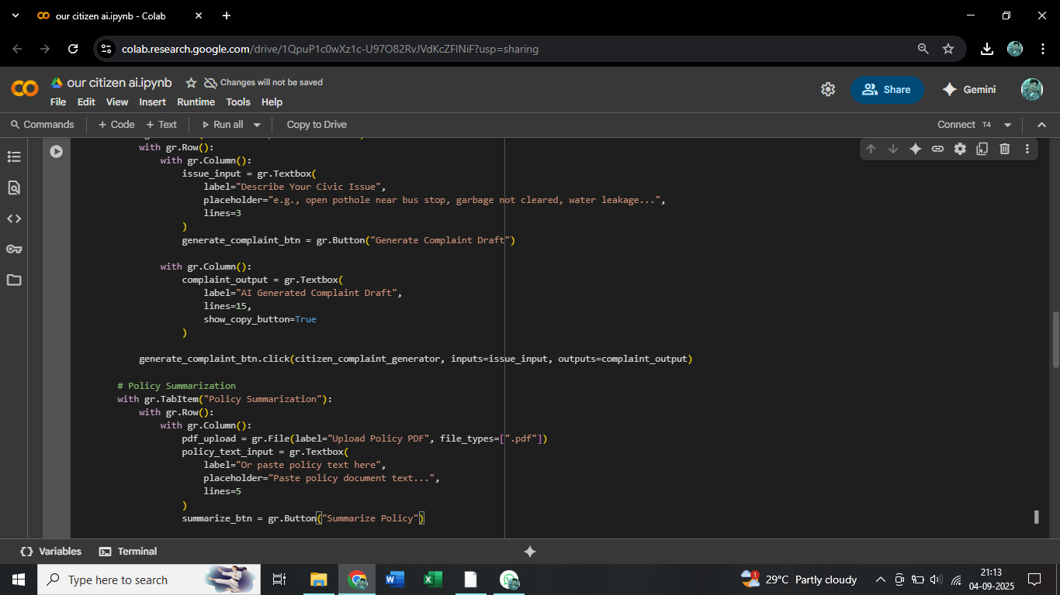

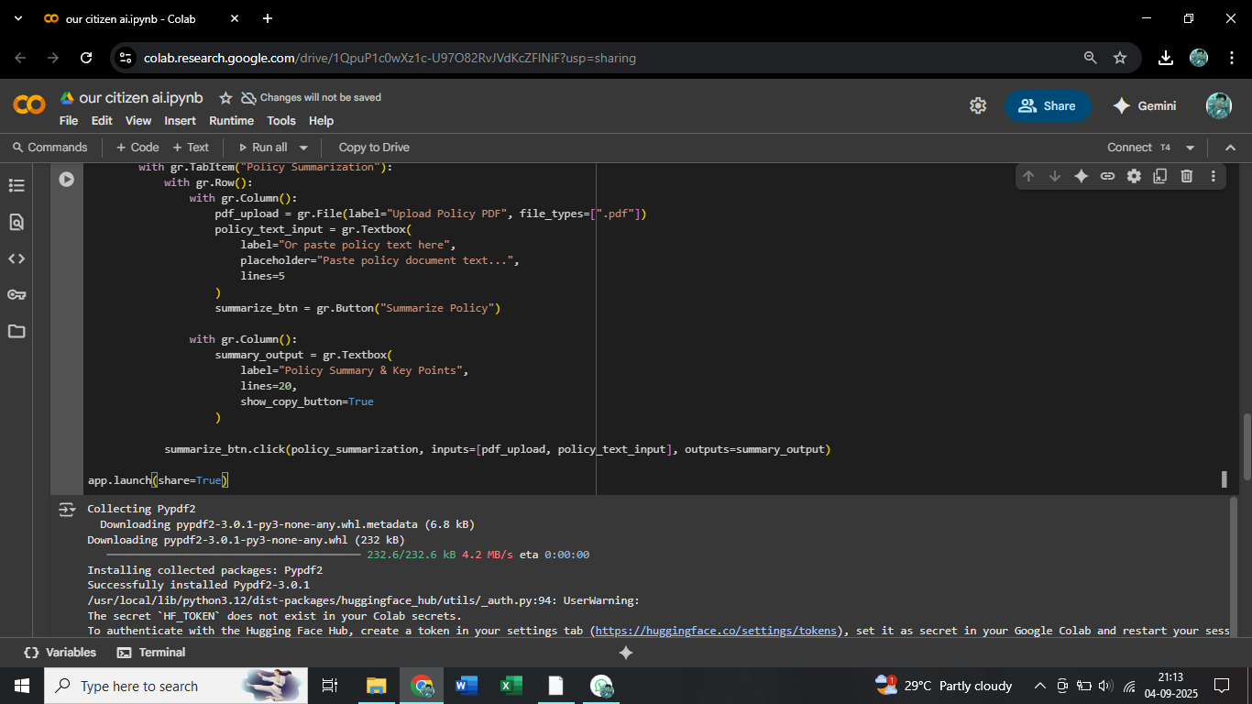

* You can find the code here in this link: [CitizenAI Code](https://drive.google.com/file/d/1y3KfSxBHtZqn12d-j2Bvz8bE-gbLuqaO/view?usp=sharing)

Output:

* Now you can see our model is being Downloaded and application is running.

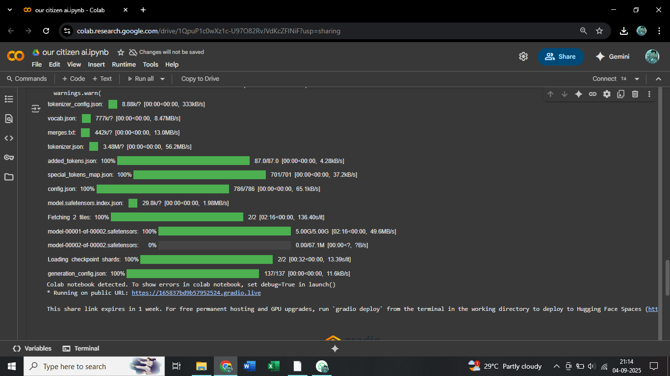

* Click on the URl to open the Gradio Application [(https://colab.research.google.com/drive/1QpuP1c0wXz1c-U97O82RvJVdKcZFlNiF?usp=sharing)](https://colab.research.google.com/drive/1QpuP1c0wXz1c-U97O82RvJVdKcZFlNiF?usp=sharing) click on the link.

Activity-4: Upload Your Project in GitHub.

* Search for “GitHub” in any browser, then click on the first link ([GitHub](https://github.com/)).
* Then click on “Signup” and create your own account in GitHub.
* If you already have an account click on “Sign in”.
* Click on “Create repository”.
* In “General” Name your repo. (Here I have given “<https://github.com/Gobika12345/citizen-AI.git>” as my repo name and it is available)
* In “Configurations” Turn On “Add readme” file Option.
* Now Download your code from Google collab by Clicking on “File”, then Goto “Download” then download as “.py”.
* Then your repository is created, then Click on “Add file” Option.
* Then Click “Upload files” to upload your files.
* Click on “choose your file”.
* Choose your project file and click on “Open”.
* After your file has Uploaded Click on “Commit changes”.

* THANKS TO SMART BRIDGE TEAM FOR GIVEN THIS OPPORTUNITY BY NM2025TMID06262 - PROJECT

TEAM.